Accenture Strategy Analyst Career Guide
Meta description: What an Accenture Strategy Analyst does, what it pays in 2026, how the Strategy Analyst Development Program hires undergrads, and how it compares with MBB.

An Accenture Strategy Analyst is the entry-level consultant in Accenture's Strategy practice, hired out of undergrad through the Strategy Analyst Development Program. A first-year Accenture Strategy Analyst in the United States earns about $90,000 in base salary and roughly $100,000 in total cash. [VERIFY: StrategyCase, July 2026; Hacking the Case Interview, August 2026] In this article, I lay out what the analyst job is, which program to apply to, what it pays, how the recruiting and the case interview run, and how the seat compares with MBB and Big 4 strategy.

Is Accenture Strategy the same as MBB?
No. Accenture Strategy is the strategy practice inside a technology and consulting firm, and it's usually grouped with tier 2 strategy firms like Oliver Wyman, Strategy& and Kearney rather than with McKinsey, BCG and Bain. The case interview looks much the same, the undergrad title is Analyst instead of Business Analyst or Associate, and entry pay runs about 25 percent lower. The biggest practical difference is that an Accenture strategy project usually hands off to Accenture's own technology and operations teams, so analysts see what happens after the recommendation. Accenture also recruits across a longer school list, which often makes the seat a realistic target for strong candidates MBB rarely interviews.

How much does an Accenture Strategy Analyst make?
About $100,000 in base and bonus in the first year: a base near $90,000 and a target bonus of roughly $9,000 to $11,000, plus a one-time signing bonus of $2,000 to $8,000 [VERIFY: StrategyCase, July 2026]. The trackers disagree at the edges. Hacking the Case Interview puts an Accenture Analyst's total at $85,000 to $95,000 across all of the firm's consulting tracks, and Glassdoor's higher $107,000 median for the "Strategy Analyst" title likely mixes in experienced hires [VERIFY: both trackers, by month]. Summer Analysts on Accenture's Summer 2027 posting, Strategy track included, earn $27 to $35 an hour in the states that require a posted pay range. [VERIFY: Accenture posting R00354373 (NAELFY27), October 2026]

StrategyCase also lists a relocation payment of $5,000 to $15,000, and both trackers put the 401(k) match near 6 percent, starting after the first year [VERIFY: StrategyCase, July 2026; Hacking the Case Interview, 2026]. After two to three years, an analyst promoted to Consultant earns about $122,000 in base, per StrategyCase, and pay rises from there [VERIFY: StrategyCase, July 2026].

What an Accenture Strategy Analyst does
An Accenture Strategy Analyst does the research, data work and first-draft analysis on strategy projects, and moves up to Consultant, the level that runs a workstream, after two to three years [VERIFY: Hacking the Case Interview, April 2026]. The Summer 2027 posting lists the work as building the business case for a transformation, designing operating models and roadmaps, tracking the value delivered against that business case, and running internal and external interviews, with charts, models, reports and presentations as the output [VERIFY: Accenture postings NAELFY26 full-time and R00354373, October 2026]. The analyst is usually the person on the team who builds the models and charts.

The projects come from the practice's offerings. Its services page lists six: Corporate Strategy & Growth, Cost & Productivity Reinvention, Operating Model & Organization Design, Product & Service Innovation, Technology Strategy and Macroeconomic Insights. Job postings add a seventh, Transaction Advisory, the team that works on deals [VERIFY: Accenture Transaction Advisory Strategy Manager posting, 2026]. Those are the names interviewers often use for their own teams, so it helps to use them in your answers.

A growth strategy project for a consumer products company might ask which of four adjacent categories to enter. The analyst sizes each category from the top down (US households, the share that buy the product, spend per household), builds a competitor map and turns notes from customer calls into a one-page view of what buyers want. The Consultant and Manager write the recommendation, and the analyst owns the numbers behind it.

A cost and productivity project for an industrial client starts with a baseline: every cost line in the client's general ledger (its master record of what it spends), mapped to the function that spends it. The analyst builds that baseline, usually in Excel or Alteryx, benchmarks it against similar companies and lists the cuts the client could make, with a dollar figure next to each. The plan often goes to an Accenture Operations or Technology team to deliver, and the analyst sometimes rolls onto that phase.

A transaction advisory project works for a buyer on a deal. Before it closes, the team checks whether the target's market is as big and as durable as the seller claims: the analyst builds the market model, tests the growth claims against third-party data and sits in on management interviews. After the deal, the same team plans the integration.

Projects usually run 6 to 15 weeks and are often followed by longer delivery work [VERIFY: Hacking the Case Interview, April 2026]. Accenture staffs regionally, so an analyst in Chicago mostly serves clients the Chicago office can reach, though the postings say employees "must be available to travel when needed" [VERIFY: Hacking the Case Interview, April 2026; Accenture posting NAELFY26, Canada]. Strategy Analysts usually work 50 to 65 hours a week, in person four or five days a week at an office or a client site. [VERIFY: Hacking the Case Interview, April 2026]

The Strategy Analyst Development Program
The Strategy Analyst Development Program is Accenture's full-time undergrad entry into Strategy, and the Strategy Summer Analyst internship is the main road into it. Strategy is one of three analyst development programs Accenture runs for undergrads, beside Consulting and Technology, and the three are separate pipelines with separate pay bands. [VERIFY: Accenture entry-level careers page, October 2026; StrategyCase, July 2026, for the pay gap between tracks] All three programs post to the same job board, so before you accept anything, confirm in writing that the offer is for the Strategy Analyst Development Program.

North America entry-level postings carry a code like NAELFY27 (North America, Entry Level, fiscal year 2027), and searching the code is the quickest way to find the right posting.

The Summer Analyst Program is a 10-week internship that starts in June and is open to students in their third year, and the Summer 2027 posting lists a graduation window of December 2027 through August 2028. [VERIFY: Accenture posting R00354373, open through October 16, 2026] That posting is the "Entry Level Advisory Summer Analyst" requisition, and it carries five tracks: Advisory Consulting, Industry X, Song, Sourcing & Procurement and Strategy. You pick the track inside the application, so select Strategy there. Locations on the Summer 2027 posting: Arlington, Atlanta, Boston, Charlotte, Chicago, Culver City, Houston, Irving, Minneapolis, Morristown, New York City, Philadelphia, San Diego and Seattle [VERIFY: same posting]. Applicants need US work authorization without sponsorship.

Each intern gets a project, a mentor Accenture calls a "buddy," and a final deliverable and presentation at the end of the summer [VERIFY: Accenture posting R00354373]. Accenture doesn't publish a conversion rate, but the return offer looks like the usual path into the program [VERIFY: "Current Accenture Summer Analysts Only" requisition, NAELFY27], and Hacking the Case Interview reports conversion "often exceeding 70 percent" for strong performers, as unofficial data [VERIFY: Hacking the Case Interview, March 2026].

For people who didn't intern, there's a direct full-time posting. Last cycle's version for Canada asked for a bachelor's or master's in any major, a graduation date between December 2025 and August 2026, and a cover letter, resume and transcript, with a deadline of July 11, 2025 [VERIFY: Accenture posting NAELFY26, Canada]. The US version usually runs on a similar clock [VERIFY: NAELFY28 posting, expected spring or summer 2027].

Accenture also lists three earlier programs on its internships and students page: a two-day virtual externship called Elevate to Innovate for first-years, an Innovation Challenge case competition for second-years, and a semester-long Student Leadership Program for second-years. None is Strategy-specific, but the Student Leadership Program can put a sophomore's name in front of Accenture recruiters a year early.

The recruiting process, step by step
Here's the calendar for the reader this article is written for: a junior in the 2026 to 2027 school year, graduating in spring 2028.

- Apply for the Summer 2027 Strategy Summer Analyst seat now. The posting says it will stay up through October 16, 2026, and Hacking the Case Interview says Accenture reads applications on a rolling basis, so earlier is better [VERIFY: Accenture posting R00354373; Hacking the Case Interview, March and June 2026]. Hacking the Case Interview puts campus deadlines in October through December, interviews December through February and decisions in March and April [VERIFY: Hacking the Case Interview, March 2026].
- Intern in Summer 2027, June through August.
- Take the return offer in August 2027, or apply that summer to the direct full-time posting for the Class of 2028, which should open in spring or summer 2027 with a deadline before fall [VERIFY: NAELFY28 posting].
- Start full time in fall 2028 as an Analyst.

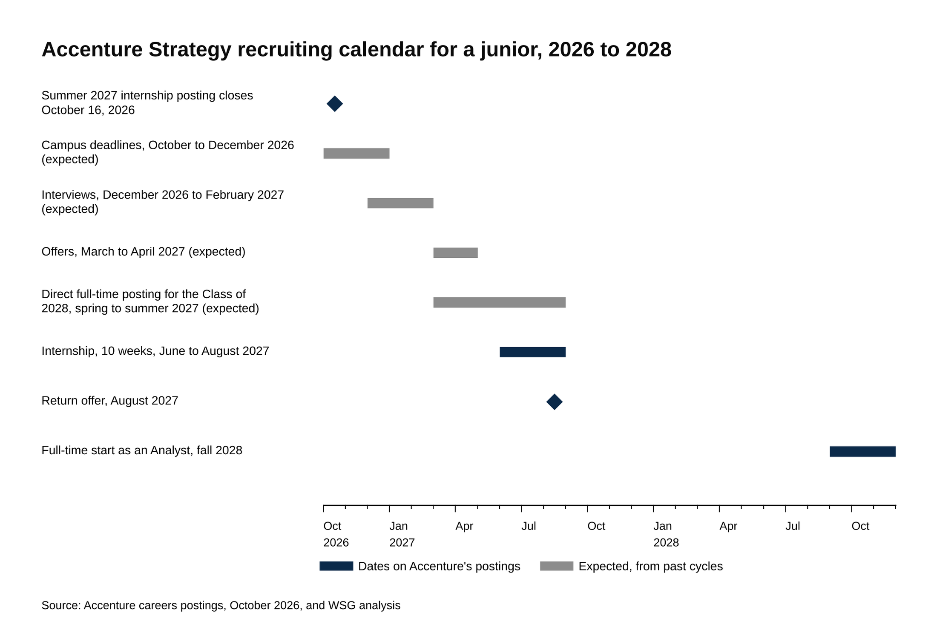
Applications for the Summer 2027 internship close October 16, 2026.
Source: Accenture careers postings, October 2026, and WSG analysis.

A sophomore graduating in spring 2029 is on the same track one year later: Student Leadership Program this year, Summer 2028 internship applied for in fall 2027, full time in fall 2029 [VERIFY: Summer 2028 posting, expected fall 2027].

The interview process has four stages, as the trackers describe it [VERIFY: Hacking the Case Interview, May 2026, and IGotAnOffer, April 2023; Accenture doesn't publish a stage list]:

- Application. A resume submitted through Workday, plus a cover letter and transcript for the direct full-time posting [VERIFY: the Summer 2027 posting R00354373 asks for neither; the NAELFY26 full-time posting required both]. Accenture lists no online assessment for the Strategy track, so the recruiter screen is usually the first test [VERIFY: current posting].
- Recruiter screen. Fifteen to thirty minutes on your background, your track preference and your locations. Have a one-minute walk through your resume ready, a sentence on why Strategy rather than the other tracks, and your first-choice office.
- First round. Two 40-minute interviews with Consultants and Managers. Each runs about 10 minutes of behavioral questions and 30 minutes of case.
- Final round. Two to three one-hour interviews with Senior Managers and Managing Directors. One is behavioral and the rest are cases, and the trackers say Strategy candidates may also get a Potentia interview, described below. Senior interviewers often push back, and Hacking the Case Interview advises holding your answer unless new information changes it. The whole process usually runs three to six weeks [VERIFY: Hacking the Case Interview, May 2026].

Accenture publishes its own case interview workbook, which describes the format (45 to 60 minutes, with 30 to 45 on the case itself) and three case types, and it's worth reading before any third-party guide. [VERIFY: workbook is the FY19 edition, copyright 2018, still hosted on accenture.com as of October 2026; the trackers put a first-round case at 30 minutes inside a 40-minute interview] "The Great Unknown" gives you one or two sentences and tests whether you can ask the right questions. "The Back of the Envelope" gives you a number to estimate and tests your arithmetic. "The Parade of Facts" gives you more detail than you need and tests whether you can set aside the irrelevant parts. The workbook says the first two are the most common, and the trackers say market sizing comes up often. The case style is usually candidate-led: you decide what to look at next and ask for the data you need, rather than the interviewer steering you [VERIFY: IGotAnOffer, April 2023; Hacking the Case Interview, June 2026].

The workbook breaks a case into six steps, and the trackers teach the same order. Listen and write down the client's objective. Clarify the problem with a few questions. Break it into an issue tree, a set of branches that don't overlap and together cover the problem. Say which branch you think explains it (your hypothesis). Test that branch by asking for the data it needs. Then close with a recommendation, the two or three facts behind it and next steps. Hacking the Case Interview calls solving the wrong problem the fastest way to fail, so confirm the objective before you build anything.

Here's one short example of those steps, using the workbook's own prompt with made-up numbers. A leading maker of prefabricated kitchen cabinets has been losing market share for two years, and the executive team wants to know why and what to do about it.

Start by clarifying: is share measured in dollars or units, what happened to the client's revenue and to the market, who does the client sell to, and what does "improve" mean? The interviewer answers: dollar share; the client's revenue has been flat at about $800 million for two years while the US market grew from $4.0 billion to $4.4 billion; and the client sells assembled cabinets to home builders and big-box retailers. So share fell from 20 percent to about 18 percent, and the question is where the $400 million of growth went.

A simple issue tree has two branches: did the growth land in a part of the market the client doesn't serve (a product type, a channel, a customer group), or is the client losing where it does compete, on price, product or distribution? The first branch is a structural problem and the second an execution problem. Flat revenue in both channels points to the first, so you ask how the growth splits by product type.

The interviewer tells you ready-to-assemble cabinets, the flat-pack kind sold online and in big-box stores, grew from $400 million to $800 million, while assembled cabinets stayed flat at $3.6 billion. The client has 21 percent of the assembled segment and 5 percent of ready-to-assemble. Check that the pieces add up: 21 percent of $3.6 billion is about $756 million, 5 percent of $800 million is $40 million, and the sum is $796 million, close to the client's $800 million. All of the market's growth came from a segment where the client barely plays.

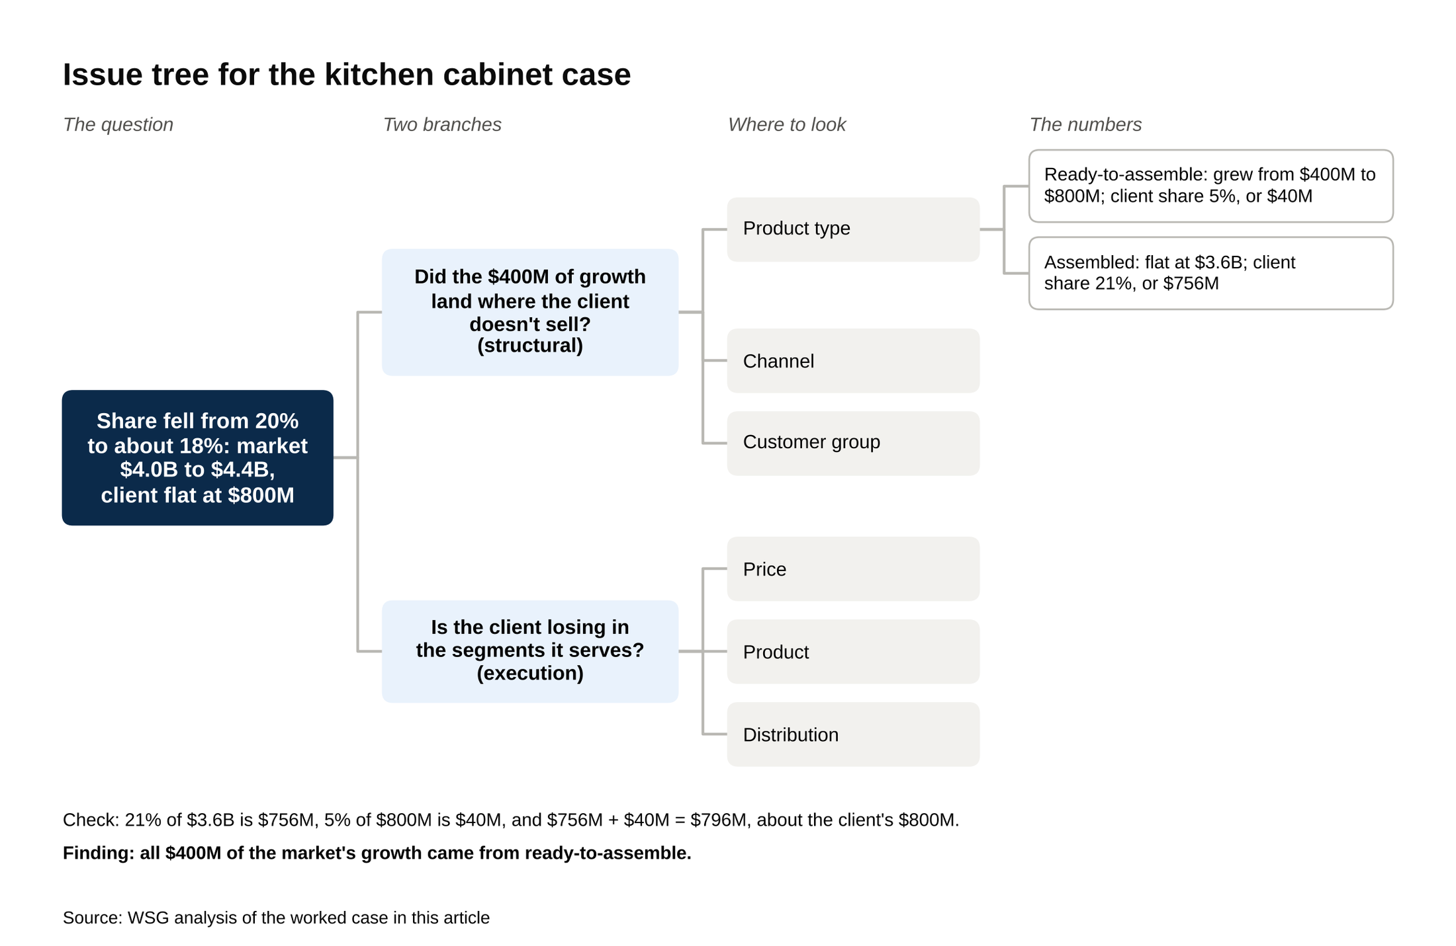
All $400 million of the market's growth came from ready-to-assemble cabinets, where the client has 5 percent share.
Source: WSG analysis of the worked case in this article.

The close takes two sentences: the share loss is a segment problem, not a brand problem, so the client should build or buy a ready-to-assemble line for online and big-box channels. The main risks are lower margins on flat-pack and cannibalizing the assembled line, so the next step is to compare ready-to-assemble margins with the cost of building or buying a line.

For a market sizing, say the equation out loud before any math (households, times the share that buy, times spend per buyer), give each input a round number and a one-line reason, talk through the arithmetic, and end by checking whether the answer looks plausible. The workbook says the interviewer wants a structured path to the number, not a precise one.

The trackers also describe a Strategy-only interview called Potentia, a discussion of a broad business prompt with five minutes to prepare and no math, which some Strategy candidates get in the final round. Hacking the Case Interview and IGotAnOffer suggest laying out four or five broad branches first, a few ideas under each, mixing ambitious ideas with ones a client could start soon, and treating the follow-up questions as a conversation. Accenture doesn't describe it publicly and it's unclear whether undergrads get it, so ask your recruiter whether your final round includes one [VERIFY: whether Potentia is used in the undergraduate Analyst and Summer Analyst process; Hacking the Case Interview, May 2026; IGotAnOffer, April 2023; Glassdoor Summer Analyst interview reports, 2019 and 2025].

The behavioral questions are usually the standard set: why Accenture Strategy, why consulting, walk me through your resume, a time you led a team through something hard, a time you managed conflict, a time you changed someone's mind, a time you failed. Four to six stories usually cover most of them. Tell each one in STAR order (the situation, your task, what you did, the result, with a number if you have one) in about two minutes. Hacking the Case Interview's advice: on a conflict question, spend most of the answer on the steps you took to resolve it, and on a failure, on what you changed afterward. WSG's guide to why consulting covers the answer almost every firm asks for.

What to show in an Accenture Strategy application
The Strategy track is usually the most selective of Accenture's undergrad programs, and the trackers put its practical GPA floor at about 3.3, against 3.0 for the rest of the firm. [VERIFY: Hacking the Case Interview, March 2026; Accenture publishes no cutoff]

Beyond the GPA, four things usually carry weight:

- A quantitative class and a tool. The postings name Tableau, Power BI, Alteryx, Python, R and SQL as preferred skills. A business or economics major with one statistics class and a Power BI project on the resume usually reads as ready. Accenture lists preferred majors (business, economics, finance, analytics, engineering, marketing, information systems, supply chain) but hires from any major [VERIFY: Accenture posting R00354373].
- A prior internship. The Summer Analyst posting lists prior internship or work experience as required. A sophomore-summer internship anywhere with a business problem in it, a research assistant job or a role in a student consulting group can all count.
- An application through the portal if Accenture doesn't recruit at your school. Accenture publishes no target list. Hacking the Case Interview names NYU Stern, Berkeley Haas and UVA McIntire as examples of the business programs the Strategy track draws from, and lists the online careers portal as an application route beside campus recruiting, which puts a candidate from any school into the same pool [VERIFY: Hacking the Case Interview, April 2026].
- A reason to want Strategy at Accenture, specifically. Hacking the Case Interview suggests having three specific reasons tied to your own background, and one can be a conversation you had with someone at the firm. The strongest answers to "Why Accenture Strategy and not MBB?" name an offering (Transaction Advisory, Technology Strategy), connect it to your experience, and say why you want strategy work at a firm that also builds the technology. For example: "I want to work on strategy questions where I see the answer get built. Accenture's strategy teams hand off to the technology and operations teams that implement, and Transaction Advisory is where I'd want to start, because the market modeling I did on my internship is the same work before a deal." Avoid "MBB is really competitive, so I'm applying broadly," which makes Accenture sound like the fallback.

Accenture Strategy vs MBB vs Big 4 strategy
Monitor Deloitte stands in for Big 4 strategy here, and WSG's Monitor Deloitte guide covers that firm in full.

Axis | Accenture Strategy | MBB | Monitor Deloitte
Year-one cash, undergrad | about $100,000 on a $90,000 base | about $135,000 to $140,000 on a $110,000 to $112,000 base | base about $90,000 to $105,000, bonus up to about $20,000
Signing bonus | $2,000 to $8,000 | about $5,000 | $15,000 to $20,000
Pre-interview assessment | none published | McKinsey Solve, BCG Casey, Bain SOVA | online assessment
Typical week | 50 to 65 hours | 55 to 65 hours | similar, less published data
Travel | regional staffing, lighter | heavier, national staffing | regional
Project type | strategy that hands off to Accenture technology and operations teams | 8 to 12 week studies, pure advice | strategy inside Deloitte Consulting
Common exits | corporate strategy, tech, some PE from Transaction Advisory | PE, tech, corporate strategy, MBA | corporate strategy; PE thinner
MBA sponsorship | up to $100,000 for the top 10 analysts in a class | full tuition plus a stipend for analysts in good standing, two-year return | Deloitte's Graduate School Assistance Program

VERIFY: pay rows against StrategyCase (July 2026), Hacking the Case Interview (2026) and WSG's Monitor Deloitte guide; hours against Hacking the Case Interview (April and May 2026); sponsorship against [Management Consulted, undated]

On project type, the question is whether you'd rather stay on and see a recommendation delivered, as Accenture analysts often do, or move to a new question every ten weeks or so, as MBB analysts usually do. If you're weighing an Accenture Strategy offer against an MBB offer, it usually makes sense to decide on project type first and pay second, since the hours and the case prep are similar.

What Strategy Analysts do after two to three years
Analysts who stay move up to Consultant. The ones who leave usually go to one of five places:

- Corporate strategy teams in the industry they served. This is often the most common exit, and the Accenture name can carry extra weight there because the hiring manager may have been a client.
- Technology companies, in strategy, operations or product roles.
- Private equity and venture, mostly for analysts with Transaction Advisory projects on their resume.
- Startups.
- Business school, with or without Accenture's MBA sponsorship.

WSG's list of consulting exit opportunities has more on each destination.

The window for an external exit is often two to four years in, once you have a Consultant title or a promotion case to point to. [VERIFY: Hacking the Case Interview, April 2026]

How to prepare, with a timeline
For a junior applying this fall, preparation runs about four weeks.

- This week: apply before October 16, with the Strategy track selected and a one-page resume that names a tool. If the posting you're applying to asks for a cover letter, write it for Accenture Strategy and name the offering you want. WSG's consulting roadmap covers the resume and the letter.
- Weeks one to three: read the workbook once, do a few cases alone, then run 15 to 20 live practice cases with a partner, at least five of them market sizings, with 15 minutes of feedback after each as Hacking the Case Interview suggests, because Accenture often leans on the back-of-the-envelope type. WSG's guide to what a case interview is and its list of seven case frameworks are good starting points.
- Week four: lock your four to six behavioral stories and your "why Accenture Strategy" answer, and ask your recruiter whether the final round includes a Potentia interview.
- Before any first round: read Accenture's most recent quarterly release (the Q4 FY26 release takes about 15 minutes) and know one thing the firm is doing in the industry you'd name.

For a sophomore, the most useful step now is a sophomore-summer internship with a business problem in it. The consulting recruiting timeline has the MBB and tier 2 dates that run alongside it, and the top consulting jobs for undergrads list shows where Accenture Strategy sits among them.

